**Dr. Sivanthi Aditanar College of Engineering.**

**Department of Information Technology.**

**Module**

Calc

Div()

Mul()

Sub()

Add()

Calc.py

def add(x,y):

return(x+y)

def sub(x,y):

return(x-y)

def mul(x,y):

return(x*y)

def div(x,y):

return(x/y)

Type this in Interactive Mode:

>>>import calc

>>>calc.add(2,3)

**Package**

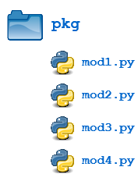

from <package_name> import *

from <package_name> import <modules_name>[, <module_name> ...]

from <package_name> import <module_name> as <alt_name>

from pkg import mod1

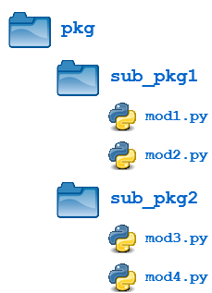

**import pkg.sub_pkg1.mod1**

**from pkg.sub_pkg1 import mod1,mod2**